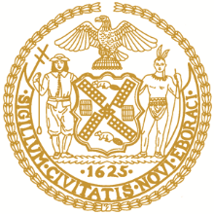
NEW YORK CITY
BOARD OF CORRECTION
May 11, 2021 9:00 AM
VIA VIDEO CONFERENCE
WebEx Event Page
PUBLIC MEETING AGENDA
- Approval of March 9 and March 17, 2021 Minutes
- Board Chair Updates
- Public Comment on Variance Request
- Presentation and Vote – Limited Variance Renewal Request to BOC Minimum Standards 1-03(c,d,j); 1-04(b)(2-3); 1-05(a-c); 1-06; 1-07(c); 1-08(f)(4); 1-08(g)(2-4); 1-09(c-d, f); 1-11(c-d); 1-12(d); 1-13(a-c); and 1-14(a-b)
  - Separation Status
- Jail Staffing – DOC
- COVID-19 Update – DOC & CHS
- New Borough Based Jails Update -- DOC
- Confidential Phone Call Recording Update - DOC
- Public Comment

